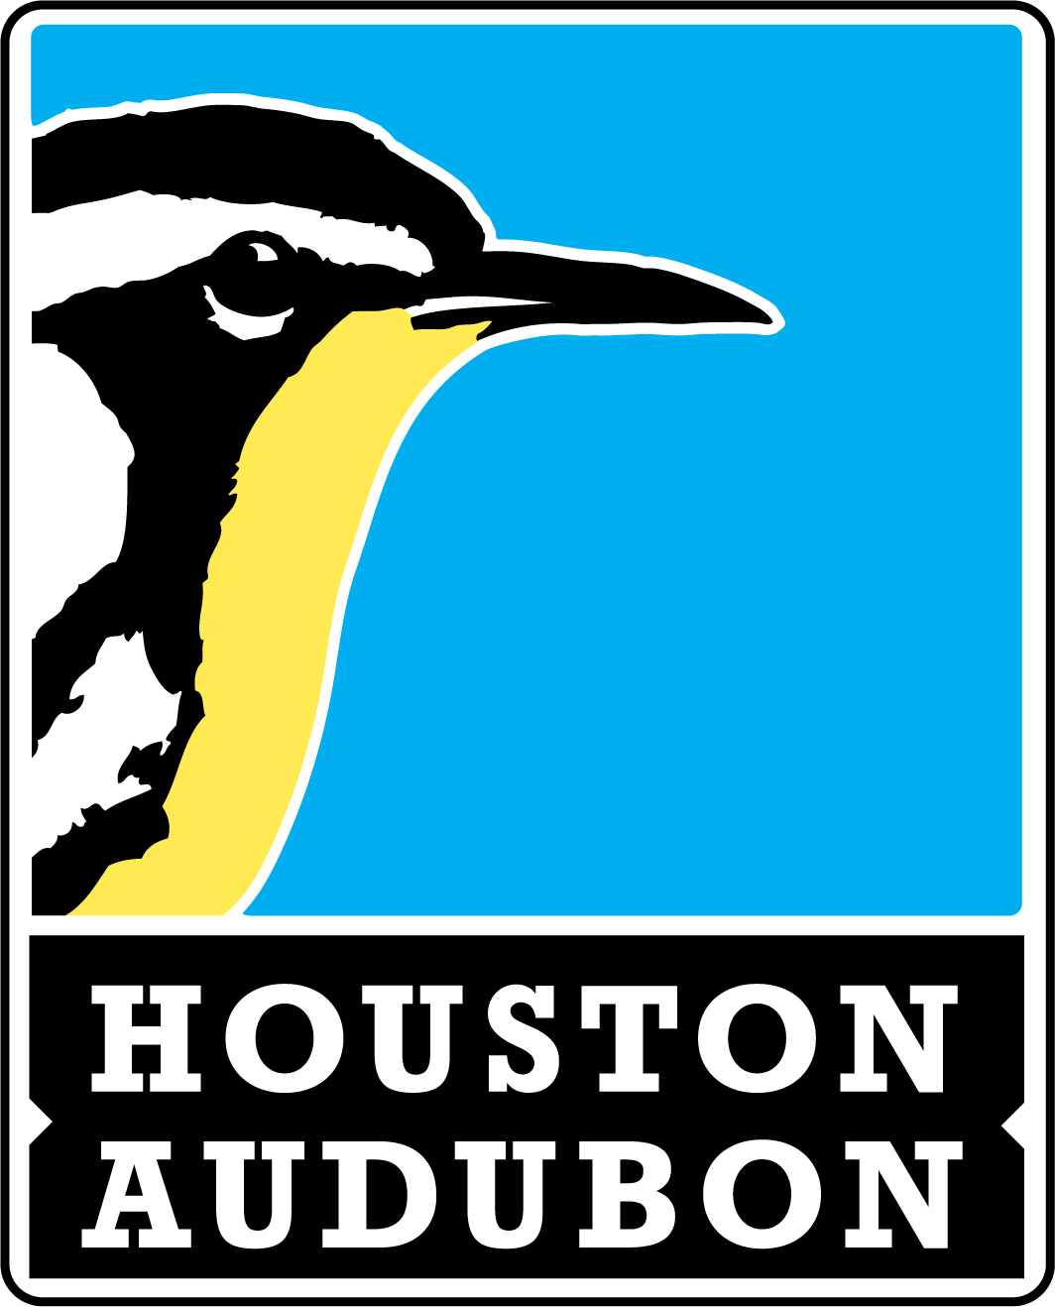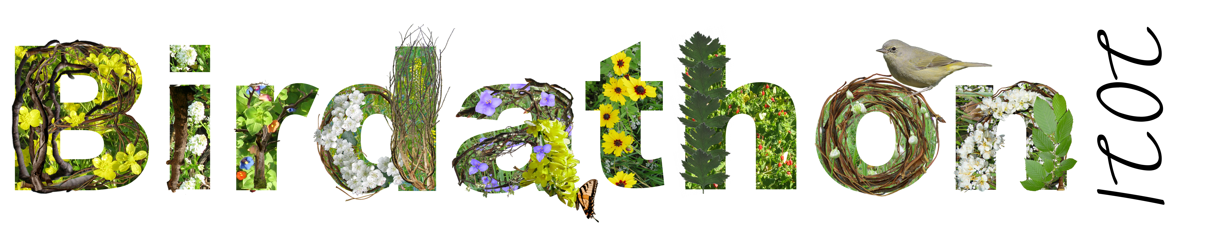

Team Report

Your team should complete and return this form to zseth@houstonaudubon.org on or
before May 10, 2021. All donations are also due at this time.

Team Name: |  |  |  | Team Leader:
Team Member Name |  |  | Email Address |  |  |  | First Birdathon? Y/N
 |  |  |  |  |  |  | Yes |  | No
 |  |  |  |  |  |  | Yes | No
 |  |  |  |  |  |  | Yes | No
 |  |  |  |  |  |  | Yes | No
 |  |  |  |  |  |  | Yes | No
 |  |  |  |  |  |  | Yes | No
(see next page to add additional names)
Date(s) and Time(s):
Location(s):
Miles Traveled:
Total Number of Species Identified:
Link to eBird Checklist:

I certify that we have complied with the Houston Audubon Birdathon 2021 Rules and the ABA Code of Ethics.
Team Leader Signature:

houstonaudubon.org/birdathon

Thank you for participating in Birdathon 2021!

