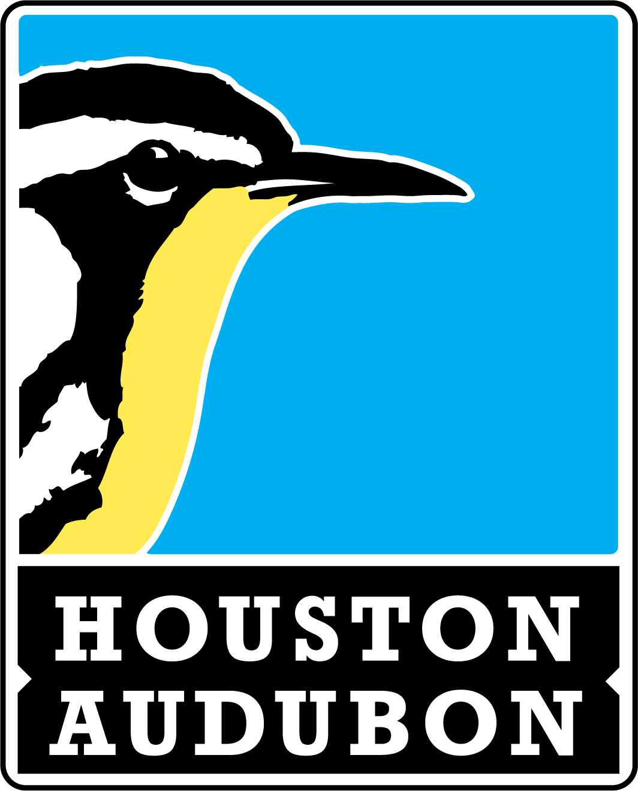

Individual Report

Your team should complete and return this form to zseth@houstonaudubon.org on or
before May 10, 2021. All donations are also due at this time.

Name: |  | Email:
Date(s) and Time(s):
Location(s):
Miles Traveled:
Total Number of Species Identified:
Link to eBird Checklist:

I certify that I have complied with the Houston Audubon Birdathon 2021 Rules and the ABA Code of Ethics.

Signature:

houstonaudubon.org/birdathon

Thank you for participating in Birdathon 2021!

