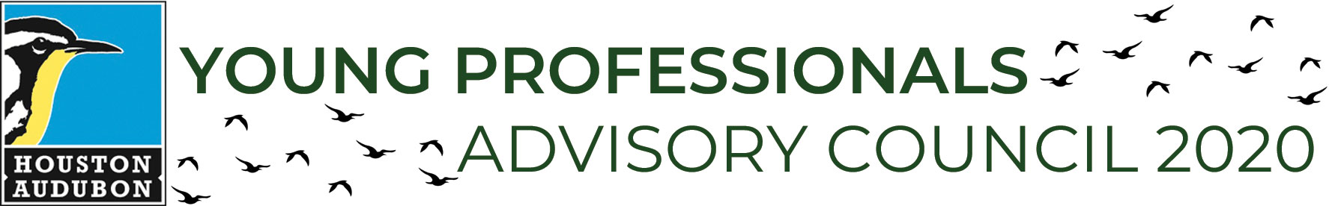

YPAC Applicant Information
YOUNG PROFESSIONALS
ADVISORY COUNCIL 2026
New member application

Full Name: |  |  |  | Date of Birth  mm/dd/yyyy
 | First | Last | M.I.

Address:
 | Street Address | Apartment/Unit #

 | City | State | ZIP Code

Phone: |  | Email

Current Employer:

Current Position:

Application Questions

Why do you want to join Houston Audubon’s Young Professionals Advisory Council (YPAC)?
Why is Houston Audubon’s mission important to you, and what is your level of involvement with the organization?
Please provide a brief description of your current job and employment history.

What skills or expertise will you bring to the YPAC?
(please include any additional languages spoken, read, or written)
What would you like to gain from serving on this council?
If selected for YPAC, which committee(s) you would be interested in joining? Please refer to the descriptions in the overview document.
□ Fundraising Events (Birdathon, Avian Affair)
□ Houston Bird Week
□ YP Social Opportunities & Engagement

How much time can you commit to the YPAC per month? We will have a combination of in-person general meetings (required) and virtual committee meetings, in addition to in-person social opportunities

Briefly tell us about yourself. What are some of your favorite things to do in your free time?
Which other organizations are you involved with (if any) and in what capacity?
Are you interested in any future leadership/chair positions?

How did you hear about YPAC?
Please share your preferred pronouns, any accommodations you may need to participate in YPAC, or anything else you would like us to know.

Application Submission

Please submit this application and one informal reference letter (can be emailed separately) to ypac@houstonaudubon.org no later than October 31, 2025.

